**Assignment 11.1 Sqoop**

**Problem Statement:**

**Mentioned all the steps:**

Perform and explain the code flow and the associated result for the below tasks. Candidates should

create and use their own employee dataset for the same. Share the screenshot of the commands used and its associated result.

for my sql : mysql -uroot –pcloudera

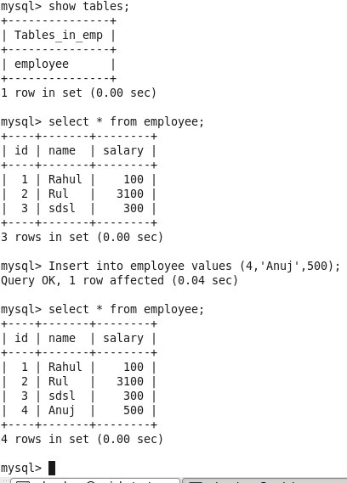

● **Transfer data between Mysql and HDFS (Import and Export) using Sqoop.**

sqoop eval --connect jdbc:mysql://localhost:3306/emp --username root --password cloudera --query "select count(*) from employee;"

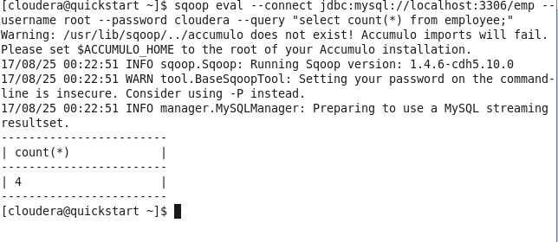

**Sqoop Import**

sqoop import --connect jdbc:mysql://localhost/emp --username root --password cloudera --table employee --target-dir sqoop_employee

sqoop import --connect jdbc:mysql://localhost/emp --username root --password cloudera --table employee --split-by id --target-dir sqoop_employee

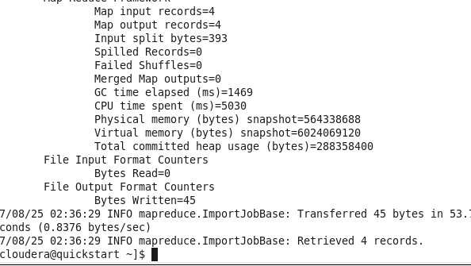

**To View data in HDFS:**

**hadoop fs -cat sqoop_emp/part-m-00000**

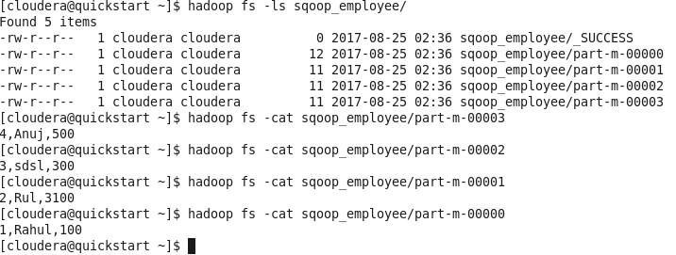

**Sqoop export**

**Goto MySQL:**

**Truncate table employee;**

**Execute below cmd**

sqoop export --connect jdbc:mysql://localhost/emp --username root --password cloudera --table employee --export-dir sqoop_employee/part-m-00003

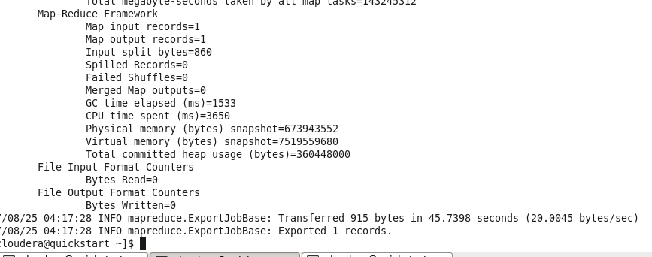

PS : **2**

**● Transfer data between Mysql and Hive (Import and Export only selected columns) using sqoop.**

sqoop import --connect jdbc:mysql://localhost/emp --username root --password cloudera --table employee --hive-import -m 1

sqoop import --connect jdbc:mysql://localhost/emp --username root --P --table employee --columns "id,name,salary" --hive-import -- target-dir sqoop_employee1 -m 1

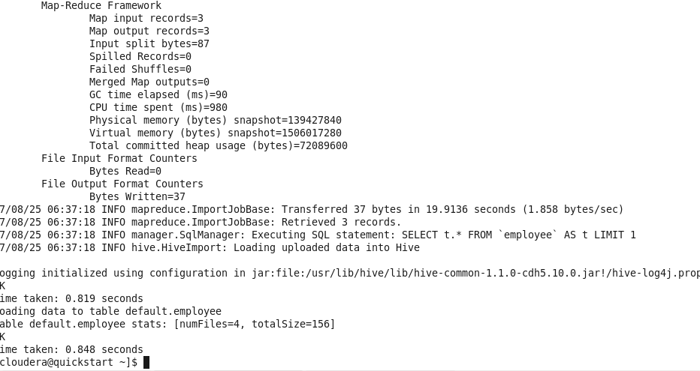

***to view in Hive:***

use default;

